PYNQ image creation for Avnet Microzed board manual
USE DOCKER ON A GOOD UBUNTU BASED COMPUTER!!
FOLLOW THE INSTRUCTIONS INCLUDING VERSIONS USED, READ LOG FILES WHEN SCRIPT CRASHES
In this manual, check which xilinx tools are compatible with your PYNQ image. I am building a PYNQ v3.0.1 iamge so I will download 2022.1 tools, on an Ubuntu 20.04.3 VM, Vbox 7.0.24. otherwise:
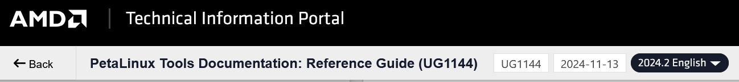
- Check operating systems compatible with Petalinux and Vitis(choose the version of petalinux you are using on the top row) :

- Download and unzip (using 7-zip) the one-file-installer for the version you need, and install Vivado on your computer.
Do not delete the installer yet, for it is needed for the virtual machine as well.
- Download and install the silicon labs cp210 usb to uart bridge
Setting up ubuntu:
getting permissions:
su -
# enter password, same as login pavisudoss
visudo
# add line at the end
tomer ALL=(ALL) NOPASSWD: ALL
(ctrl+o to write out, then enter, then ctrl+x to exit)
exit # leave root user mode
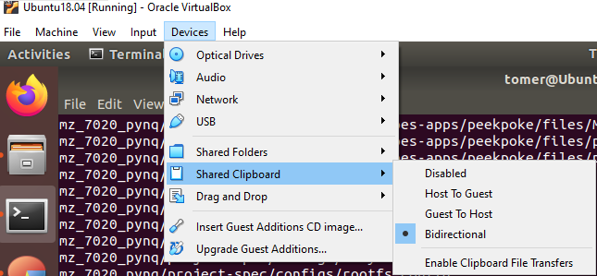
Allow clipboard transfer from host-guest:
(choose bidirectional in the path shown below)

On the top --> Devices --> Insert Guset Additions CD image (hit return to close it when it finishes)
sudo reboot
Install all prerequisites: (Run the first two sudo commands twice in order to solve update problems)
sudo apt update
sudo apt-get install -y build-essential dkms linux-headers-$(uname -r) gcc git make net-tools libncurses5-dev tftpd zlib1g-dev libssl-dev flex bison libselinux1 gnupg wget diffstat chrpath socat xterm autoconf libtool tar unzip texinfo zlib1g-dev gcc-multilib libsdl1.2-dev libglib2.0-dev zlib1g:i386 screen pax gzip cpio python3 python3-pip python3-pexpect xz-utils debianutils iputils-ping python3-git python3-jinja2 libegl1-mesa pylint3 iproute2 gawk gperf help2man libtool-bin ninja-build libpixman-1-dev libslirp-dev libtinfo5

Changed pylint3 to pylint:
sudo apt update
sudo apt-get install -y build-essential dkms linux-headers-$(uname -r) gcc git make net-tools libncurses5-dev tftpd zlib1g-dev libssl-dev flex bison libselinux1 gnupg wget diffstat chrpath socat xterm autoconf libtool tar unzip texinfo zlib1g-dev gcc-multilib libsdl1.2-dev libglib2.0-dev zlib1g:i386 screen pax gzip cpio python3 python3-pip python3-pexpect xz-utils debianutils iputils-ping python3-git python3-jinja2 libegl1-mesa pylint iproute2 gawk gperf help2man libtool-bin ninja-build libpixman-1-dev libslirp-dev libtinfo5
git clone https://github.com/crosstool-ng/crosstool-ng.git
cd crosstool-ng
./bootstrap
./configure --prefix=/usr/local
make
sudo make install
dpkg -S /usr/bin/qemu-arm-static
sudo apt-get update
cd ~
wget https://download.qemu.org/qemu-5.2.0.tar.xz
tar -xf qemu-5.2.0.tar.xz
cd qemu-5.2.0
./configure --target-list=arm-linux-user --static
make -j $(nproc)
sudo cp ~/qemu-5.2.0/build/arm-linux-user/qemu-arm /usr/bin/qemu-arm-static
sudo chmod +x /usr/bin/qemu-arm-static
qemu-arm-static --version

Mount shared folder:
# Add shared folder in the virtualbox window--> shared folders --> +-->, choose path to shared folder, name it and check automount and make permanent
sudo mkdir -p /mnt/cdrom
sudo mount /dev/cdrom /mnt/cdrom
cd /mnt/cdrom
sudo ./VBoxLinuxAdditions.run
sudo usermod -aG vboxsf tomer #(change tomer to your username)
sudo reboot

Install Vitis:
Take the zipped file from windows (or other host os) --> move to shared folder
sudo mkdir -p /home/tomer/Xilinx
tar -xzvf /media/sf_shared_folder/ Xilinx_Unified_2022.1_0420_0327.tar.gz -C /home/tomer/xilinx
cd /home/tomer/Xilinx_Unified_2022.1_0420_0327
./xsetup
Follow the installer, install vitis (will install vivado as well) in /home/tomer/xilinx
Install PetaLinux:
cp /media/sf_shared_folder/petalinux-v2022.1-04191534-installer.run /home/tomer/xilinx/
cd ./home/tomer/xilinx/Petalinux/petalinux-v2020.2-final-installer.run
Build the hardware file for the Petalinux BSP:
- Open Vivado, create a new project, choosing the microzed board in the project creation section. If you don't have the board, search for its BDF in the web
for example: Avnet Boards BDF, and follow instructions supplied there.
- Build the base overlay needed for the image.
- Some very important notes:
  - From my understanding, you can not change the ps settings of the base overlay. For example:
If you made the base overlay allowing the SPI0 for MIO10-15 in the MIO configuration, it will not be reversible.
  - If you will not allow SD0 in the base overlay, the SD boot will not work (currently just a speculation).
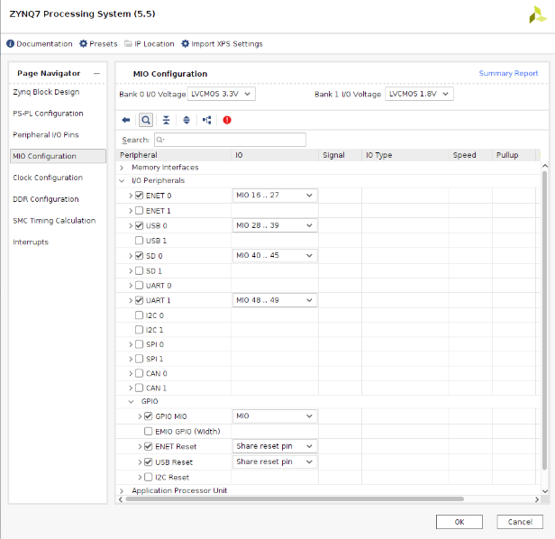
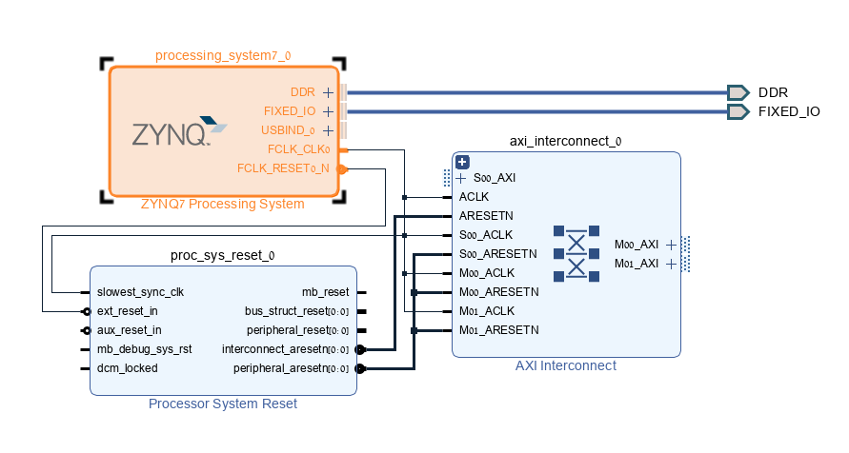
- I used this design:

- After building the block design:
- Create HDL wrapper
- Generate bitstream
- Export hardware, include bitstream (put it in the shared_folder, should be a .xsa)

After the installation is complete, do the next steps according to Adam Taylor's guide: (this steps build the bsp of the image so it takes time)
source /home/tomer/xilinx/Petalinux/settings.sh
petalinux-create --type project --template zynq --name mz_7020_pynq
#put the hardware file in the new directory named mz_7020_pynq
cd mz_7020_pynq
petalinux-config --get-hw-description /home/tomer/xilinx/Petalinux/mz_7020_pynq #no need to write the file, just the directory. Exit the petalinux screen.
petalinux-build
petalinux-package --boot --uboot --fpga
petalinux-package --bsp -p mz_7020_pynq -o mz_7020_pynq.bsp

Building the image:
git clone https://github.com/Xilinx/PYNQ
cd PYNQ
cd boards
mkdir -p mz_7020_pynq
cd mz_7020_pynq
#move BSP file to the new directory
nano mz_7020_pynq.spec #create the mz_7020_pynq.spec txt file, and write the following lines to it:
ARCH_mz_7020_pynq:= arm
BSP_mz_7020_pynq:= mz_7020_pynq.bsp
STAGE4_PACKAGES_MZ_7020_PYNQ:= pynq ethernet
## use ^o to write, enter to approve, ^x to exit
cd ../.. ##exit to pynq directory
git checkout image-v3.0.1
source /home/tomer/xilinx/settings.sh ##source petalinux
source xilinx/Vivado/2022.1/settings64.sh
source xilinx/Vitis/2022.1/settings64.sh
./PYNQ/sdbuild/scripts/setup_host.sh
cd PYNQ/sdbuild
make BOARDS=<board>
## A few eternities later, the build should finish and wait at the: /home/PYNQ/sdbuild/output/mz_7020_pynq directory
Booting the device:
Use BalenaEtcher to upload the .img file to a SD card. You should see these files:
BOOT.BIN, boot.py, boot.scr, image.ub, REVISION
- Check that the usb cable is disconnected
- Ensure that the Jumpers are on SD boot mode
- Connect the ethernet cable to the board
- Insert the SD card to the its slot
- Connect usb cable.
- Open TeraTerm:
- Close the ssh connection window that pops at the beginning
- On the top ruler, choose setup --> serial connection.
- Choose the right com port, baud rate and other settings according to your board.
- Press the reset button on the board and see the booting sequence in the Teraterm terminal.
- Connect to Jupyter Notebooks by browsing to pynq:9090 in a firefox browser.
- If there is no connection, try running this in the terminal:
sudo ip link set eth0 up
#password: Xilinx
sudo ifconfig eth0 192.168.2.99 netmask 255.255.255.0
And then check again

Build errors:
There are some errors with broken links that appear in the full-build (without the prebuilt image)

- 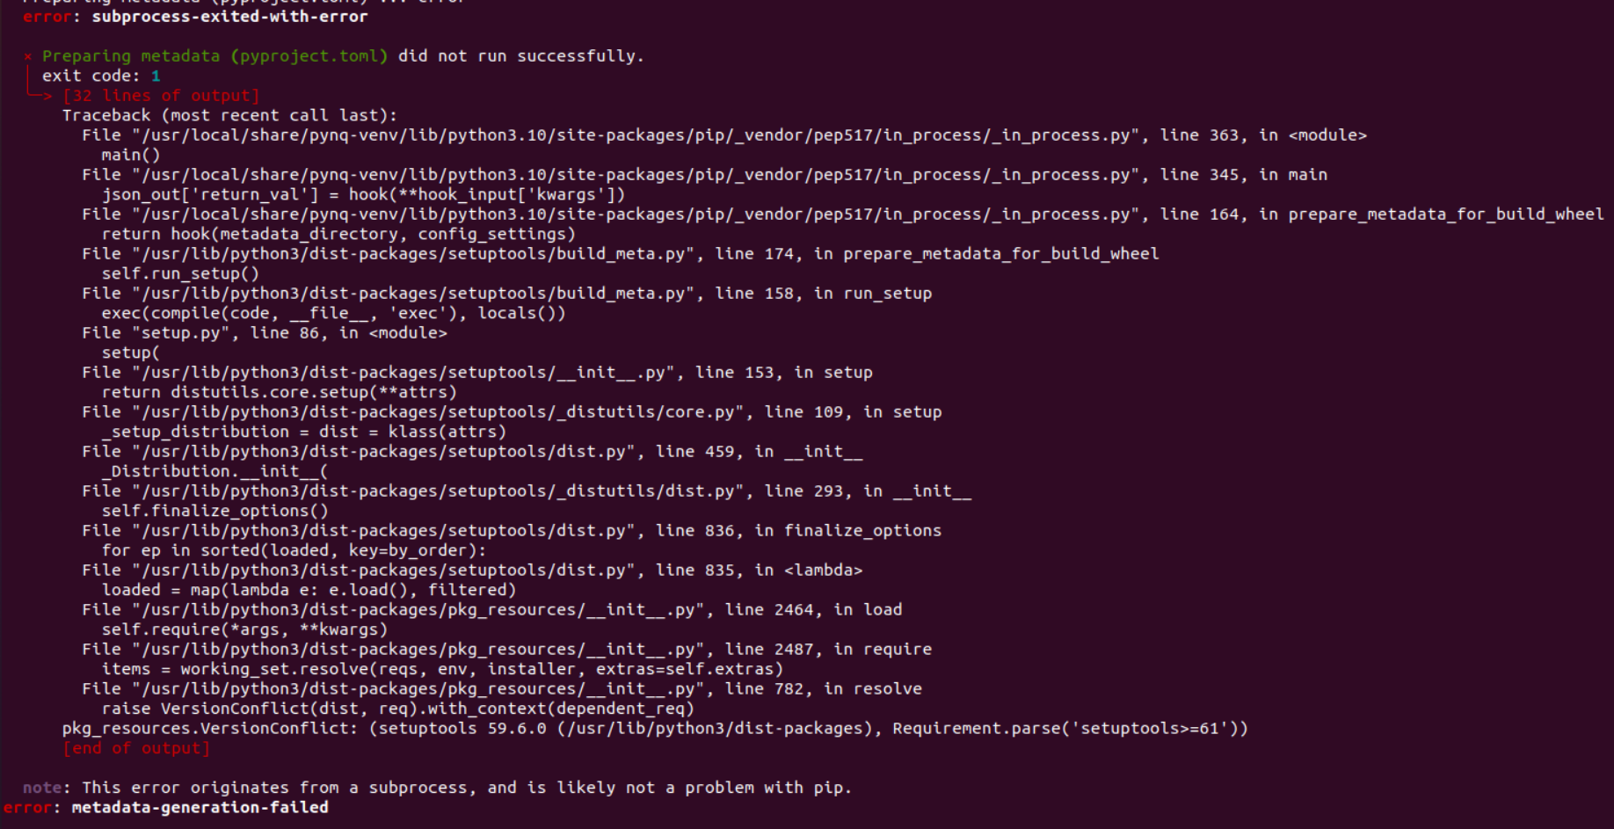
Solution:
In this script:
/home/tomer/PYNQ/sdbuild/packages/python_packages_jammy/qemu.sh
add this line
python3 -m pip install --upgrade setuptools
before this line:
python3 -m pip install -r requirements.txt
did not solve. Something about the virtual environment.
- in these places:
/PYNQ/sdbuild/build/gcc-mb/samples/aarch64-linux-gnu,microblazeel-xilinx-elf
/PYNQ/sdbuild/build/gcc-mb/samples/arm-linux-gnueabihf,microblazeel-xilinx-elf
/PYNQ/sdbuild/packages/gcc-mb/samples/aarch64-linux-gnu,microblazeel-xilinx-elf
/PYNQ/sdbuild/packages/gcc-mb/samples/arm-linux-gnueabihf,microblazeel-xilinx-elf
Change this line:
CT_GCC_DEVEL_URL="svn://gcc.gnu.org/svn/gcc"
To this line:
CT_GCC_DEVEL_URL=https://github.com/gcc-mirror/gcc.git
- in: /home/tomer/PYNQ/sdbuild/packages/gcc-mb/Makefile:20
change line 20 to this line:
cd ${GCC_MB_WORKDIR} && ct-ng arm-unknown-linux-gnueabihf && sed -i -e 's:2.4.1:2.2.6:' -e 's|CT_ISL_MIRRORS=.*|CT_ISL_MIRRORS="https://distfiles.macports.org/isl/"|' -e 's|CT_EXPAT_MIRRORS=.*|CT_EXPAT_MIRRORS="https://github.com/libexpat/libexpat/releases/download/R_2_2_6"|' .config && ct-ng build

